Name: Alvyn Abranches

Class: FY MSc Data Science and Big Data Analytics

Roll No 1

Exercise 1

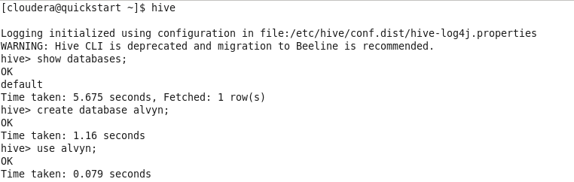



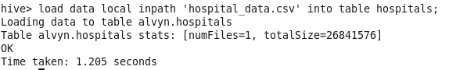



Exercise 2

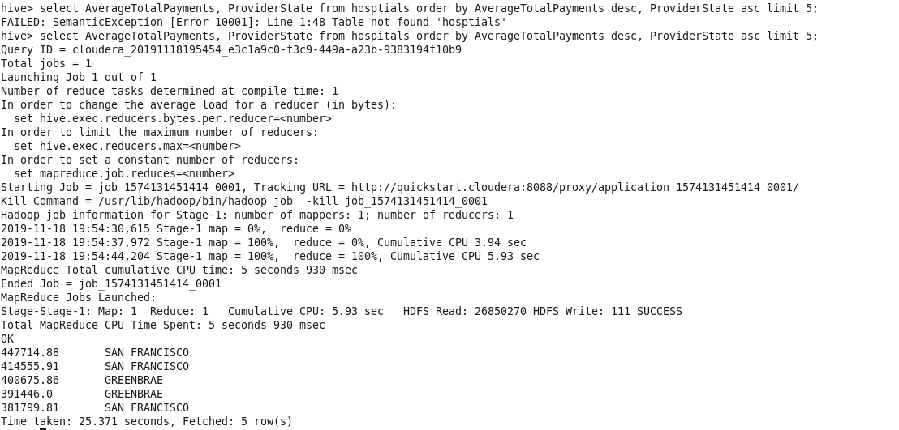

Exercise 3

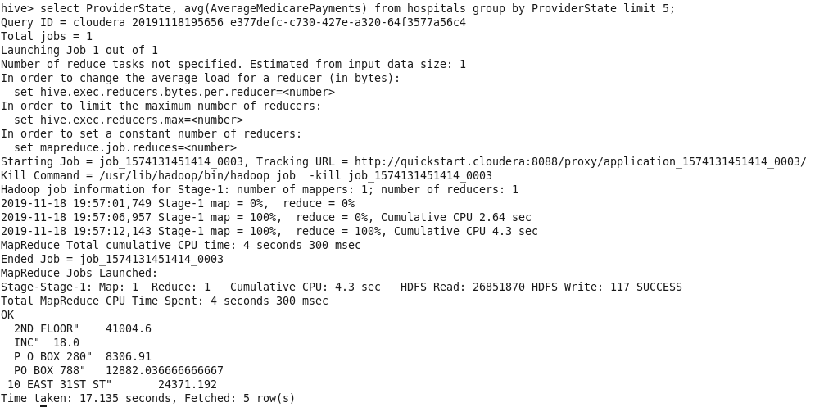

Exercise 4



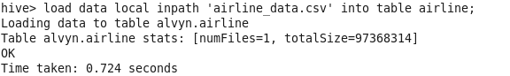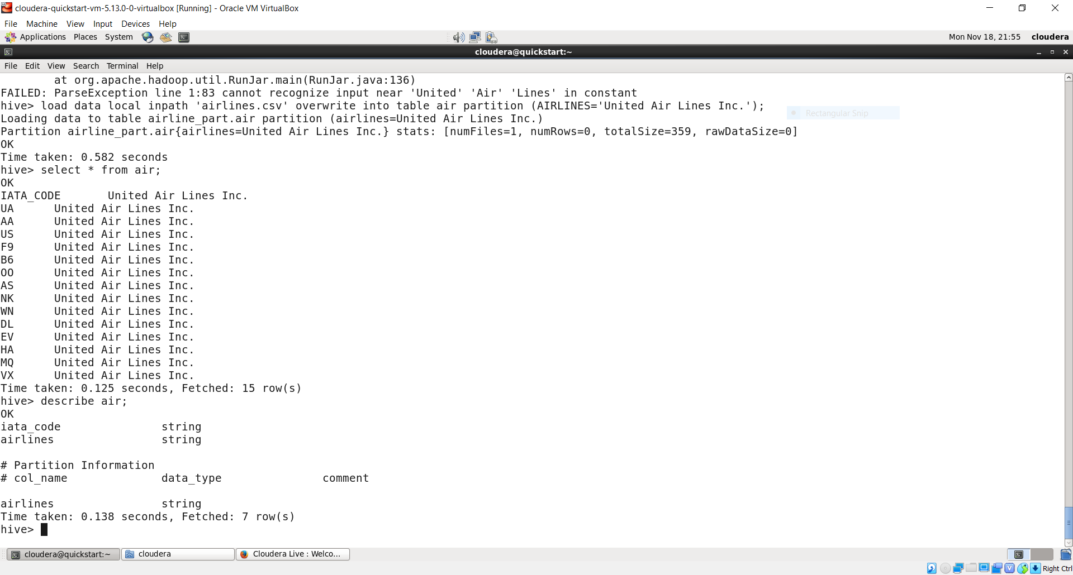

Exercise 5



Exercise 6

Map Side Join